Emre Kurt
Introduction to Data Science
Professor Wallisch
5/19/21
Big Data Analysis Project

Missing values were treated on a case by case basis per question. Depending on its relevancy to the question, they were either removed or imputed using the mean. Dimension reduction was done using sklearn’s algorithms.

- Correlation between the number of applications and admissions to HSPHS

To find this correlation, new Dataframes were extracted from the main dataset. These datasets are the columns ‘acceptances’ and ‘applications’. The correlation coefficient was calculated using numpy’s “corrcoef” function.
The resulting coefficient was 0.8, meaning a higher number of applications is associated with a higher number of admissions to HSPHS. The resulting scatter-plot illustrates how schools with application numbers under 100 achieved a lower admission rate.
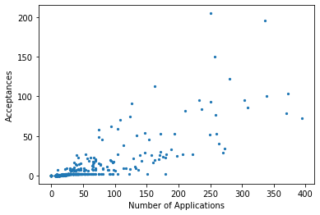

However, this does not account for school population, as addressed in the second question.

- Raw number of applications versus application rate as a predictor of admissions
Using the Shapiro-Wilks test, we can safely say both our response variable (acceptances) and predictor variables are highly skewed (p-value well under 0.01). These values were then put through logarithmic transformation (np.log(applications - (min(applications) – 1))).
After transformation, we can use the R-squared value to determine how much of the variance each predictor explains. Raw application numbers give us an R-squared of 0.60.
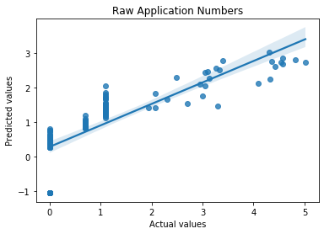
The regression with the application rate gives us an R-squared of 0.5.

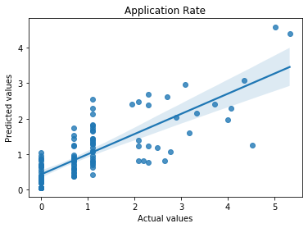
From here, we can say the model with raw application numbers as a predictor does a greater job at predicting acceptances. However, due to the multi-dimensional nature of this dataset, it is unlikely that one variable is sufficient enough for prediction.
- School with highest per-student odds of HSPHS admissions

The per-student odds of entering an HSPHS can be acquired by dividing the total number of admissions granted to the school by its student population. From here, it is seen that The Christia McAuliffe School (I.S. 187) has the highest chance of HSPHS admission, with odds of around 23:77.
Schools with no size information available were excluded from the calculation.

- Relationship between school perception and measures of achievement
First, we must assess whether PCA is a valid choice to go about simplifying our model. Initially, the data must be imputed using sklearn’s SimpleImputer (using means), due to the presence of NaN values. Then, the predictors are placed into a correlation matrix:
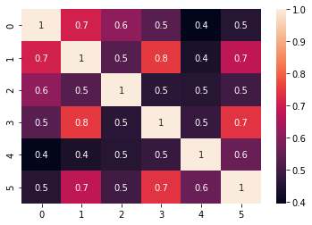
From here, we can safely say all the predictors are not uncorrelated. This warrants a PCA projection. The same analysis can be done for the outcomes, measures of achievement:
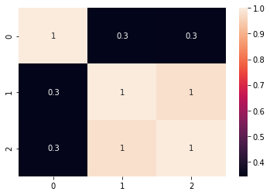
“Student achievement” appears to only be sparsely positively correlated with the other achievement factors, but we can still use it.

Reducing the two sets of variables and correlating them gives us a coefficient of 0.36. This is a moderate positive relationship. If we perform a t-test, using this formula,
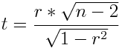

,where r is the regression coefficient and n is the sample size. We have a t-value of 9.39, and when looked up on a t-table, this yields a significant p-value (under 0.01). This means there is a positive relationship between a good (higher) school perception and the academic achievement of its students.

5. Do schools with a higher percentage of poverty experience lower chances of entering HSPHS?
For the purposes of this experiment, schools with a poverty percentage above 50% will be considered poor, and those under 50% will be considered rich. Poor will be categorized as 1, and rich will be categorized as 0. To put into perspective:
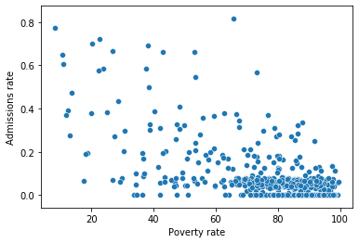
Then, acceptance rates that corresponded with poor schools were separated from those from the rich schools, and a Mann-Whitney U-test was done to find a statistically significant difference between the two groups. This is because the dataset violates many of the assumptions needed for an independent samples t-test. The results are a p value of 2.15x10^-6. This provides us with evidence to reject the null hypothesis that states no difference between the HSPHS admissions rate of poorer students versus that of richer students.

6. Material resources and academic achievement

First, we can check for a relationship between indicators of the material affluence of schools. In this case, it will be per-pupil spending, class sizes, and collaborative teachers, respectively. NaN values are imputed.
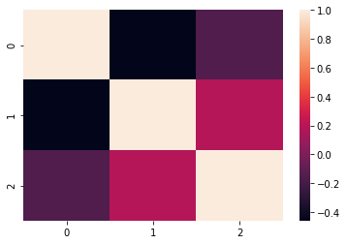
According to the heatmap, per-pupil spending and class sizes are slightly negatively correlated. Collaborative teachers share a negligible relationship with either of the other two variables. This does not give us enough ground to justify a PCA reduction.
Next, we can check for a linear relationship between per pupil spending, class sizes, collaborative teachers and objective measures of treatment and HSPHS admission. Using the PCA reduced academic achievement sample in the previous question, we can take a look at the resource variables’ scatter-plots.
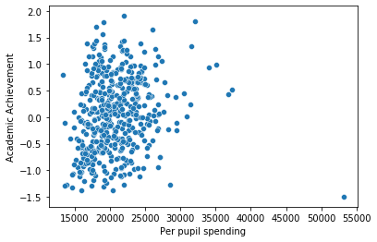
At first glance, the only identifiable relationship with academic achievement appears to be a positive one with per-pupil spending. Using Pearson’s r, we see that their correlation coefficient is 0.16, with a significant p-value.

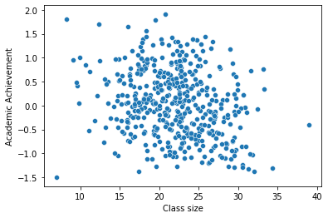
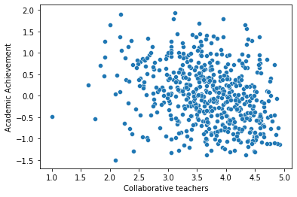
Checking the other variables yields a correlation coefficient of -0.27 for collaborative teachers and academic achievement. Class sizes and achievement have a coefficient of -0.21.
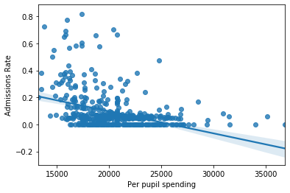
For these variables and the schools’ respective HSPHS admissions rate, the following plots are seen.
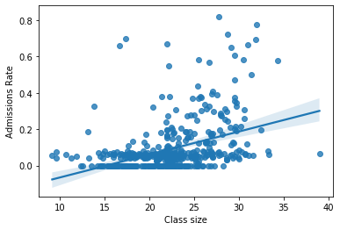
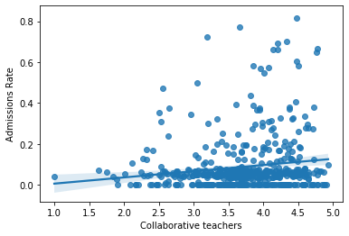
Per pupil spending and HSPHS admissions rates are negatively correlated with a coefficient of -0.33. Class sizes and admissions are positively correlated with a coefficient of 0.37. Finally, collaborative teachers and admissions have a positive correlation coefficient of 0.14.
All three of these indicators of a school’s resources have some, but not a large effect both on a school’s academic performance nor its HSPHS admissions rate.

7. Proportion of schools accounting for 90% of all students accepted into HSPHS

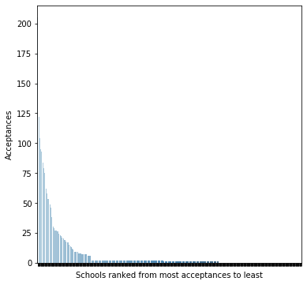
After looping through and using numpy’s array sorting methods, 90% of all acceptances given by HSPHS (4015/4461) were given to 123 schools. In other words, 21% of schools in NYC make up for 90% of all acceptances into HSPHS. As seen in the bar chart, the acceptance rate is quite disproportionate.
8. A model to predict HSPHS acceptance or academic performance

In order to efficiently predict an outcome, we should look to do some dimension reduction of the predictors. For HSPHS admission, academic performance is included. NaN values were imputed. First, the data is z-scored to put it on a standard normal distribution. Then, a scree plot is generated to make out what factors should be kept when building the model.
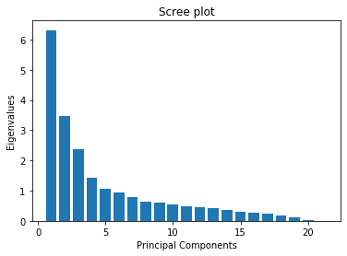
We can use 1 as the cutoff (Kaiser). This leaves us with 4 retained factors.
Factor 1, when looked at its weight on the predictors, can be classified as academic prowess.
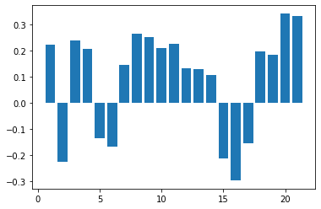

Factor 2 can be classified as school support:
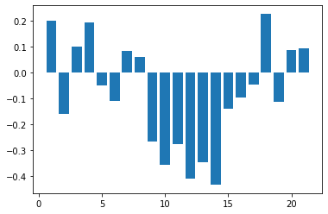

For the sake of simplicity and time, I will use only the first two factors.
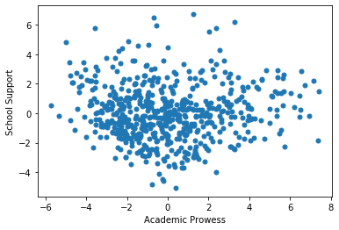

When placed next to admissions rates:
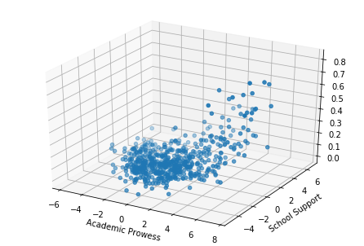
From the chart, we can see that a higher amount of school support leads to a higher admissions rate (when coupled with academic prowess). To verify this, we can use an SVM model. Acceptances rates were converted into categorical data using its median, where 1 is a high acceptance rate and 0 is a low acceptance rate. The model reports a 69% accuracy rate for predicting a schools admissions chances (in terms of whether it is higher than other schools or not).

To predict academic prowess, we can use the third omitted factor from the PCA above, which can be classified as English language proficiency, due to its association with students from diverse ethnic backgrounds and the schools’ ESL program:
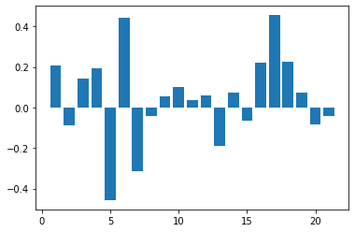
Academic prowess is turned into a categorical outcome with 1 being above average and 0 being below average.
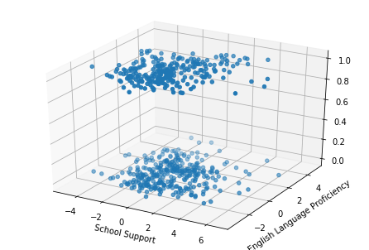

When put through an SVM model, this time it had an accuracy of 58%.

9. Overall summary

What the models have done is attempt to map how much each trait of a school affects its chances of entering HSPHS. At first glance, the raw number of applications may seem like a good predictor of admissions, but there are possible confounds at play there. For example, material resources and income level may influence how many students actually apply to HSPHS. By reducing the number of variables into independent smaller dimensions, we can somewhat understand that academic prowess (how students in each school perform on objective measures of achievement) and school support (how well-funded and organized the schools infrastructure is) are the biggest indicators of a schools entry into HSPHS. This makes sense since both of these factors can influence application numbers.

10. Suggestions

Firstly, I would improve student and teacher engagement on campus. Student support is one of the biggest predictors of both HSPHS admissions and academic prowess. This can be through clubs, extracurricular activities, or special events. When students have a welcoming environment to be around 7 hours a day, this may motivate them to apply themselves more. Secondly, upping rigorous academic challenges can be of great benefit to students wishing to get into HSPHS. Reducing class sizes and updating teacher quotas (giving more incentive to be collaborative) can also improve student academic performance.

